**Advance Javascript**

**Module-1**

1. **Write a program to Show an alert.**

**Ans.**

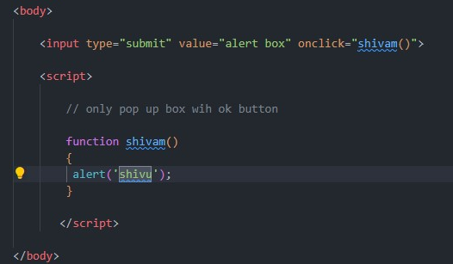

1. **What will be the result for these expressions?**

**Ans.**

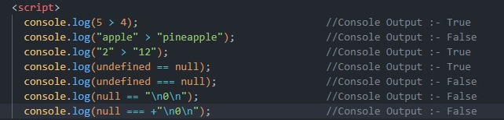

1. **Will alert be shown?**

**Ans.**

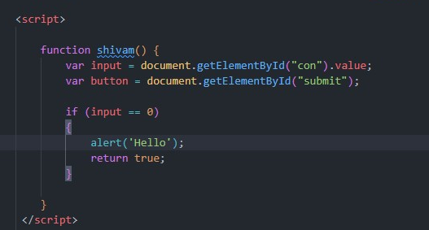

1. **What is the code below going to output? alert( null || 2 || undefined );**

**Ans.** 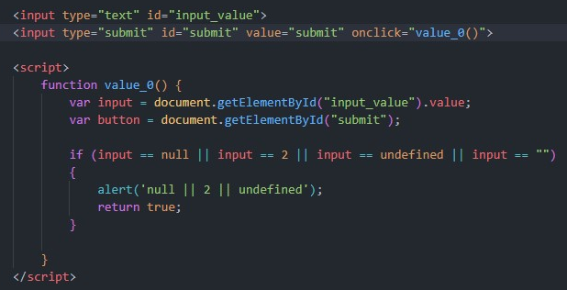

1. **What is the code below going to output? alert( null || 2 || undefined );**

**The following function returns true if the parameter age is greater than Otherwise it asks for a confirmation and returns its result:**

**Ans.** 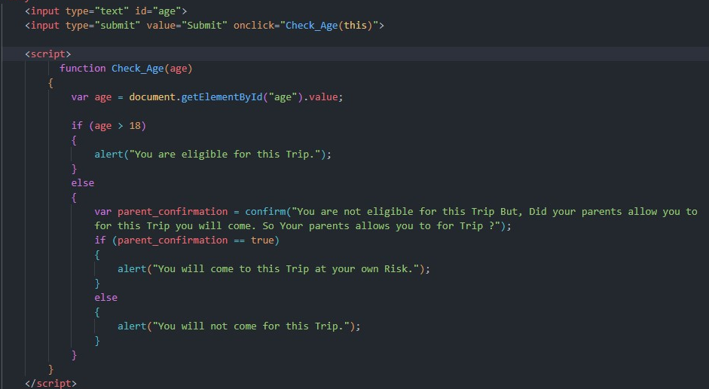

1. **Replace Function Expressions with arrow functions in the code below:**

**Ans.** 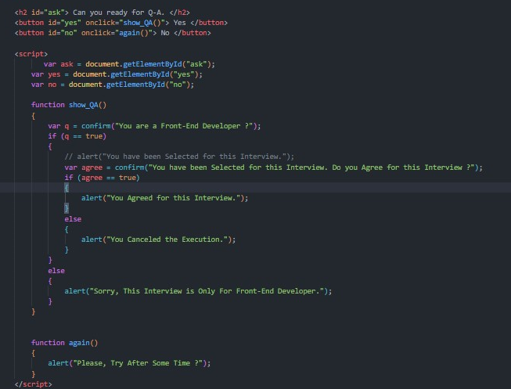

**Module – 2**

1. **Write the code, one line for each action:**
2. **Create an empty object user.**

**Ans.** 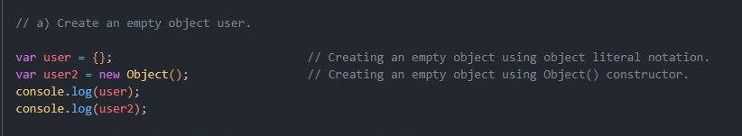

**B) Add the property name with the value John.**

**Ans.**

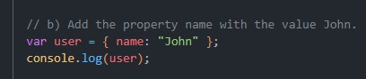

**C) Add the property surname with the value Smith.**

**Ans.**

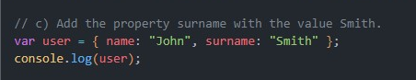

**D) Change the value of the name to Pete.**

**Ans.**

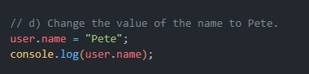

**E)**  **Remove the property name from the object.**

**Ans.**

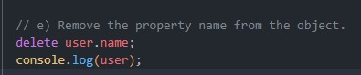

1. **Is array copied?**

**let fruits = ["Apples", "Pear", "Orange"]; // push a new value into the "copy" let shoppingCart = fruits; shoppingCart.push("Banana"); // what's in fruits?**

**alert( fruits.length ); // ?**

**Ans.** 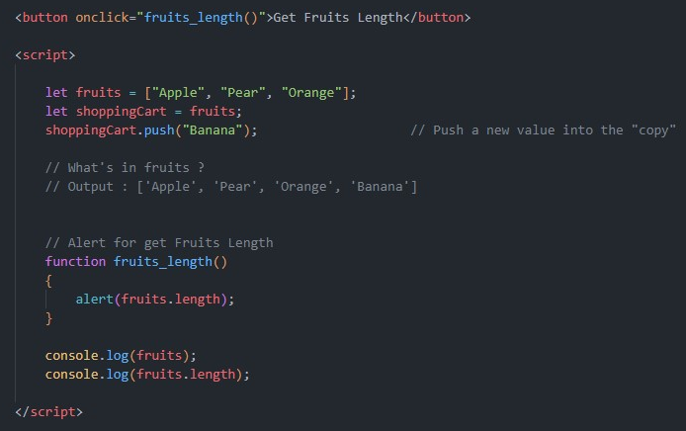

1. **Map to names**

**let john = { name: "John", age: 25 }; let pete = { name: "Pete", age: 30 }; let mary = { name: "Mary", age: 28 }; let users = [ john, pete, mary ]; let names = /* ... your code */ alert( names ); // John, Pete, Mary**

**Ans.** 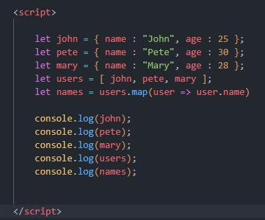

1. **Map to objects.**

**Ans.**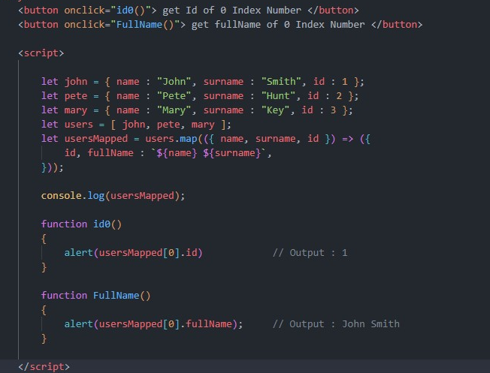

1. **Sum the properties There is a salaries object with arbitrary number of salaries. Write the function sumSalaries(salaries) that returns the sum of all salaries using Object.values and the for..of loop.If salaries is empty, then the result must be 0.**

**Ans.**

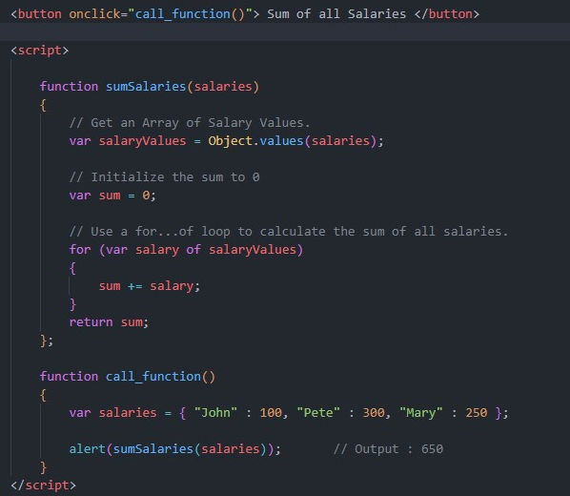

1. **Destructuring assignment We have an object:**

**Write the Destructuring assignment that reads: a) Name property into the variable name. b) Year’s property into the variable age. c) isAdmin property into the variable isAdmin (false, if no such property) d) let user = { name: "John", years: 30};**

**Ans.** 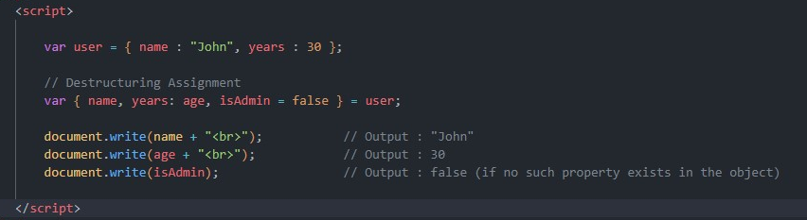

1. **Turn the object into JSON and back Turn the user into JSON and then read it back into another variable.**

**Ans.** 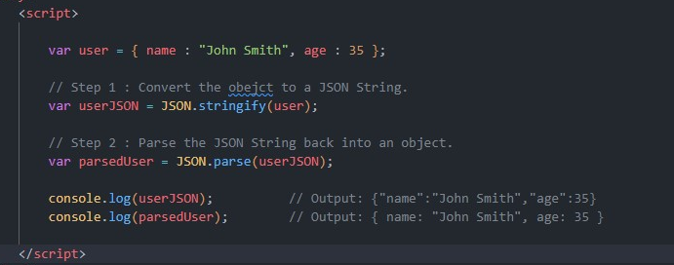

**Document, Event and Controls**

1. **Create a program to hide/show the password**

**Ans.**

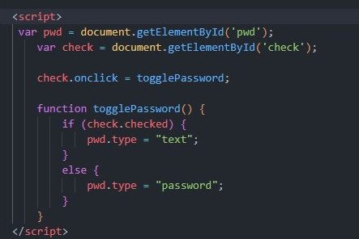

1. **Create a program that will select all the classes and loop over and whenever i click the button the alert should show**

**Ans.** 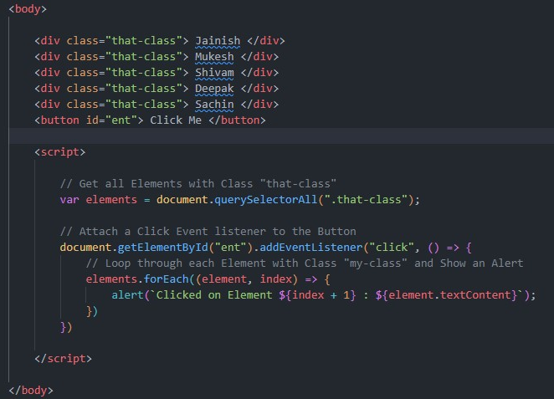

1. **Create a responsive header using proper JavaScript**

**Ans.** 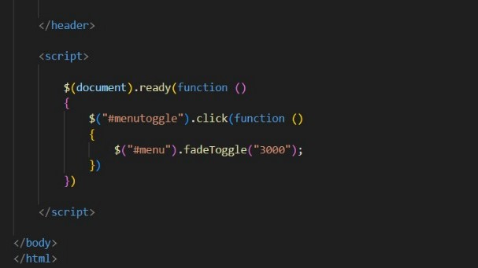

1. **Create a form and validate using JavaScript**

**Ans.** 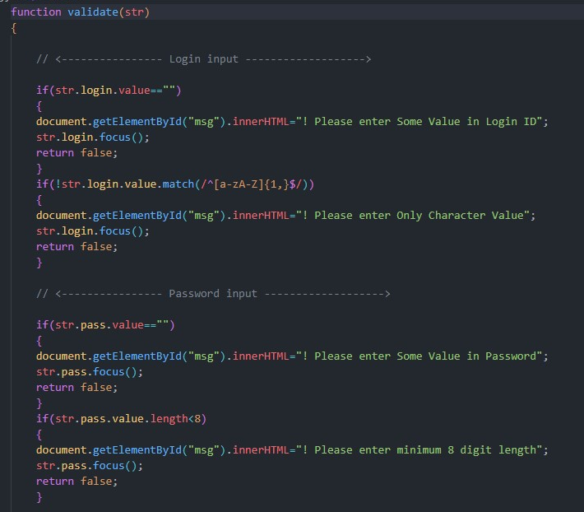

1. **Create a modal box using css and Js with three buttons**

**Ans.** 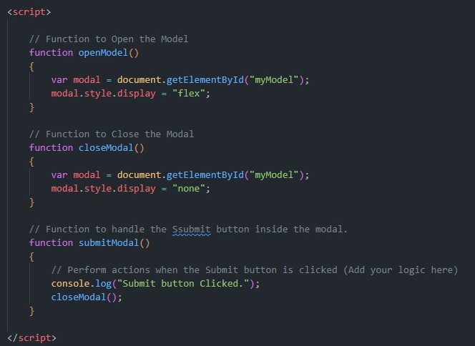

1. **Use external js library to show slider**

**Ans.**

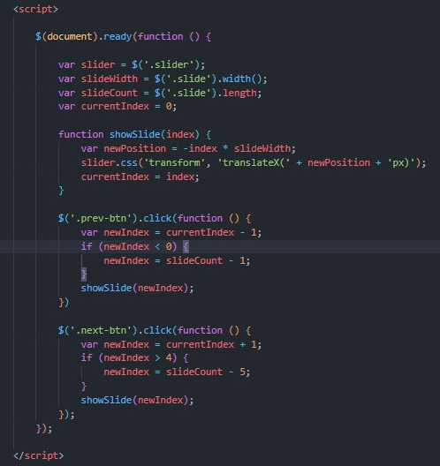

1. **Prevent the browser when i click the form submit button**

**Ans.** 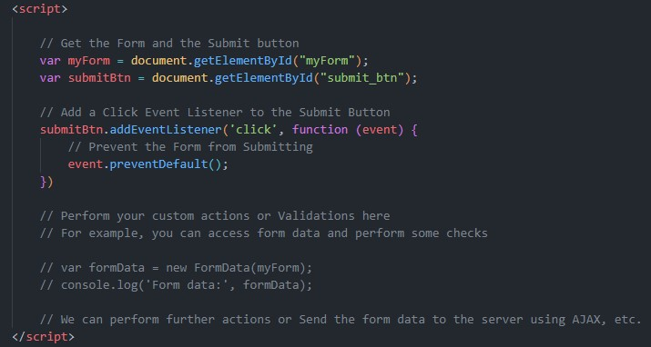

# New Request

1. **What is Json ?**

**Ans. JSON stands for “JavaScript Object Notation”, and it is a lightweight data interchange format. JSON is commonly used for transmitting data between a server and a web application as an alternative to XML.**

1. **What is promises ?**

**Ans.** A Promise is an object representing the eventual completion or failure of an asynchronous operation. Since most people are consumers of already-created promises, this guide will explain consumption of returned promises before explaining how to create them

1. **Write a program of promises and handle that promises also**

**Ans.** 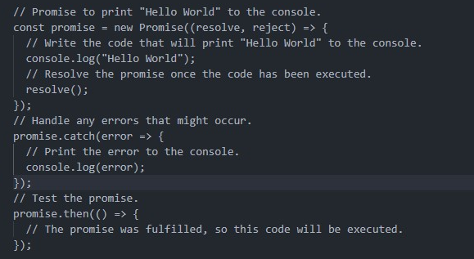

1. **Use fetch method for calling an api** [**https://fakestoreapi.com/products**](https://fakestoreapi.com/products)

**Ans.** 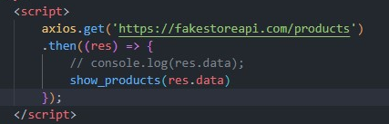

1. **Display all the product from the api in your HTML page**

**Ans.** 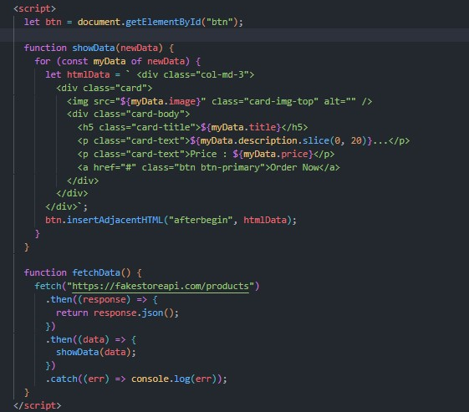

# JavaScript Essentials

1. **Calculate subtotal price of quantity in JavaScript?**

**Ans.** 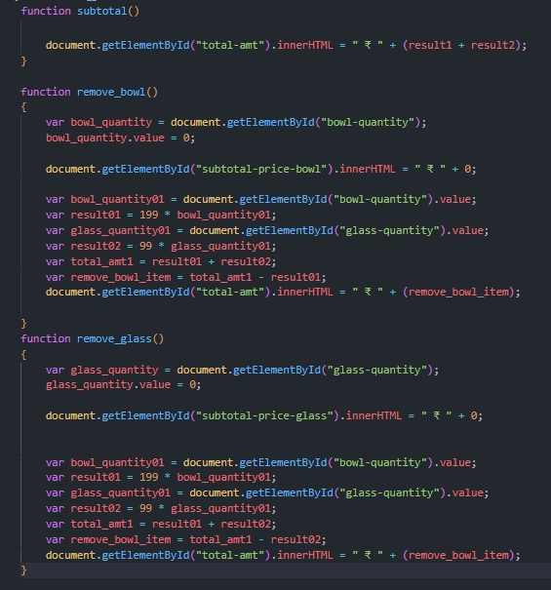

1. **What is JavaScript Output method?**

**Ans.** JavaScript Methods: A JavaScript method is a property of an object that contains a function definition. Methods are functions stored as object properties. Object method can be accessed with the following syntax: Syntax: object = { methodName: function() { // Content } }; object.methodName()

1. **How to used JavaScript Output method?**

**Ans**

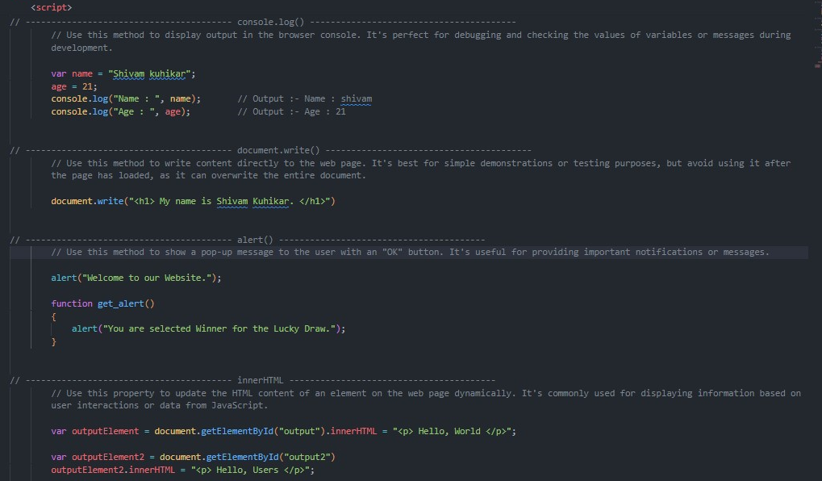

4 **How to used JavaScript Events to do all examples?**

**Ans.** 